AVL Trees

References
Data Structure Techniques, Standish, 1980, section 3.7.3
Handbook of Algorithms and Data Structures, Gonnet, 1984, section 3.4.1
http://www.eli.sdsu.edu/courses/fall96/cs660/notes/avl/avl.html#RTFToC5

Height-Balanced Trees
Height of a tree is the length of the longest path from the root to a leaf.
A binary search tree T is a height-balanced k-tree or HB[k]-tree, if each node in the tree has the HB[k] property
A node has the HB[k] property if the height of the left and right subtrees of the node differ in height by at most k.

Some HB[2] Trees

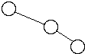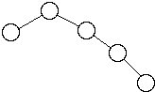
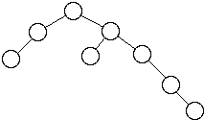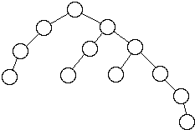

AVL Trees
A HB[1] tree is called an AVL tree.
Adel'son-Vel'skii and Landis first defined HB[1] trees
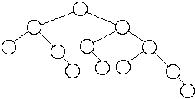

Worst Case AVL Trees

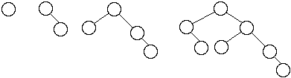

Let = the number of nodes in worst case AVL tree of height n
We have:

Fibonacci Numbers
, ,
n
0 | 1 | 1
1 | 2 | 1
2 | 4 | 2
3 | 7 | 3
4 | 12 | 5
5 | 20 | 8
6 | 33 | 13
We get
But 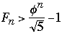where
So 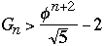

Now take any AVL tree of height h with M nodes, we have
M >= 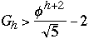
So M + 2 > 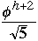
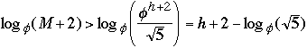
h < 1..4404 lg(M + 2) - 0.328
Theorem ( Adel'son-Vel'skii and Landis 1962) The height of a balanced tree with N internal nodes always lies between lg (N +1 ) and 1..4404 lg(M + 2) - 0.328

Insertion into a AVL Tree
Some notationBalance Information
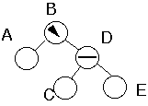

Height of Subtrees
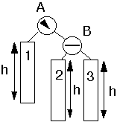
Insert key as normal binary search tree
Restructure the tree if some node are unbalanced

Case 0Inserting into Short Subtree
Balance Information ChangesNo Restructure of Tree
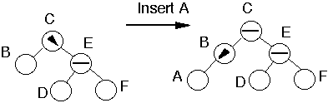
General Case
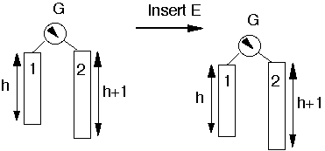
or
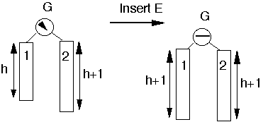

Case 1a
Insert into taller subtreeTaller subtree balancedTaller subtree on RightInsert into outer subsubtree
Example
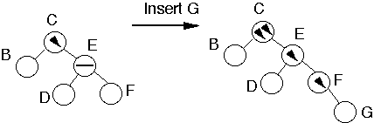
Perform Single Rotation
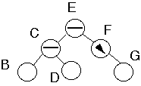
Tree is balanced

Need for Generalized Case 1a
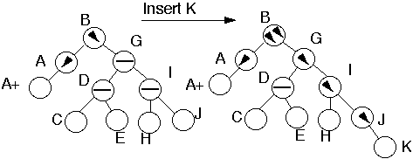

Case 1a
Insert into taller SubtreeTaller Subtree balancedTaller subtree on RightInsert into outer subsubtree
Add node to subtree 3
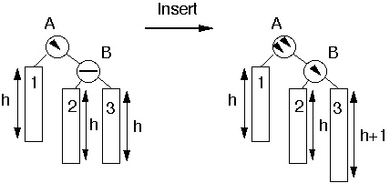
Perform Single Rotation
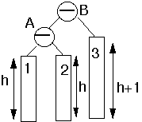
Tree is balanced

Case 1b
Insert into taller subtreeTaller subtree balancedTaller subtree on LeftInsert into outer subsubtree

This is symmetric to case 1a

Example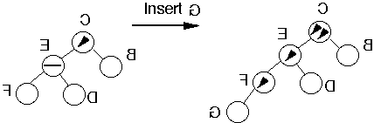
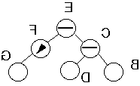

Case 2a
Insert into taller subtreeTaller subtree balancedTaller subtree on RightInsert into inner subsubtree

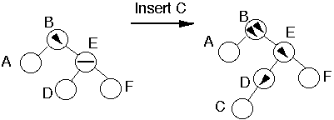
Double Rotation
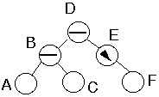

Case 2a
Insert into taller subtreeTaller subtree balancedTaller subtree on RightInsert into inner subsubtree
Insert into subtree 2 or 3
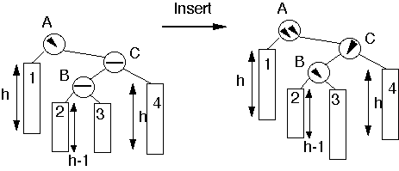

Double Rotation
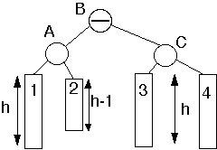

Case 2b
Insert into taller subtreeTaller subtree balancedTaller subtree on LeftInsert into inner subsubtree
This is symmetric to case 2a

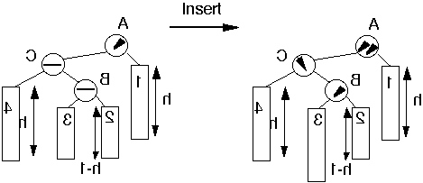

Case 3a
Insert into taller subtreeTaller subtree unbalancedTaller subtree on RightTaller subsubtree on RightInsert into outer subsubsubtree
Insert K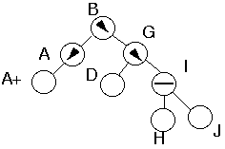
Reduces to Case 1aInsert K
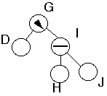
We have covered all cases!

Deletions from an AVL Tree
Delete the node as in a binary search tree
The node deleted will be either a leaf or have just one subtree
Since this is an AVL tree if the deleted node has one subtree, then that subtree contains only one node
Traverse up the tree from the deleted node checking the balance of each node

Case 1a
Traversing Up from Left subtreeDeletion reduced the height of the left subtreeNode has equal balance
Action:
Change balance of the node and stop
Have not effected the balance of any higher nodes
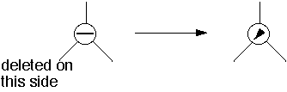
Case 1b
Traversing Up from Right subtreeDeletion reduced the height of the Right subtreeNode has equal balance
Action:
Same as 1a

Case 2a
Traversing Up from Left subtreeDeletion reduced the height of the left subtreeLeft subtree was greater then the right subtree
Action:
Change balance of the node and stop
May have effected the balance of any higher nodes, so continue up tree
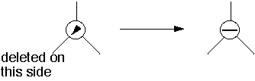

Case 2b
Traversing Up from Right subtreeDeletion reduced the height of the Right subtreeRight subtree was greater then the Left subtree
Action:
Similar to 2a

Case 3a
Traversing Up from Left subtreeDeletion reduced the height of the left subtreeRight subtree was greater then the Left subtree Left subtrees has equal subsubtrees
Action:
Perform single rotation, Adjust the balance
Have not effected the balance of any higher nodes
Stop here
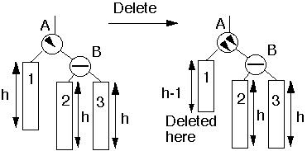
Single Rotation
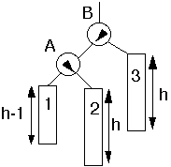

Case 4a
Traversing Up from Left subtreeDeletion reduced the height of the left subtreeRight subtree was greater then the Left subtree One or both of B subtrees has height h-1
Action:
Double rotation at B
May have effected the balance of any higher nodes, so continue up tree
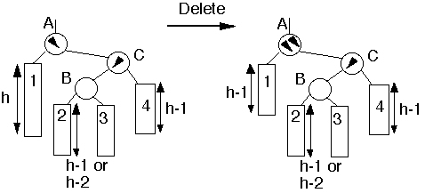
Double Rotation
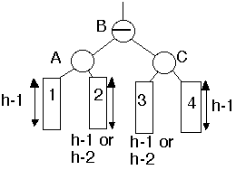

Case 5a
See picture
Action:
Single rotation at B
May have effected the balance of any higher nodes, so continue up tree
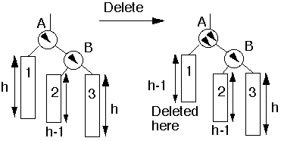
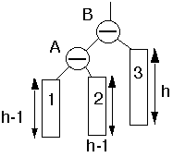

Performance of AVL Trees
Theorem. An insertion into an AVL tree requires at most one rotation to rebalance a tree. A deletion may require lg(N) rotations to rebalance the tree.
Simulation Results AVL
n | C(n) | E[ h(n) ] | R(n)
5 | 2.2 | 3.0 | 0.213
10 | 2.907 | 4.0 | 0.318
50 | 4.930 | 6.947 | 0.427
100 | 5.889 | 7.999 | 0.444
500 | 8.192 | 10.923 | 0.461
1000 | 9.202 | 11.998 | 0.463
5000 | 11.555 | 14.936 | 0.465
10000 | 12.568 | 15.996 | 0.465
n = number of nodes in the tree
C(n) = average number of comparisons to find a key
E[ h(n) ] = expected height of tree
R(n) = average number of rotations per insertion/deletion

